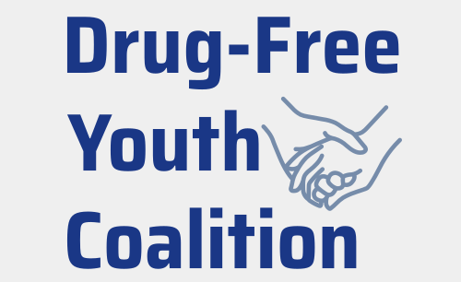

May 31, 2026

Dear Community Stakeholder,
My name is Samantha, and I am a community nurse educator as well as the founder of the Drug-Free Youth Coalition. After losing my middle school-aged son to suicide, I became deeply aware of the mental health and suicide crisis affecting youth in York County. Through the coalition, I have transformed my pain into a passion for building communities where young people feel inspired, supported, and empowered to thrive. Our mission is to improve the health and wellness of vulnerable populations.
The Drug-Free Youth Coalition is a 501(c)(3) organization that operates under the proven framework of the Drug-Free Communities (DFC) Support Program, the nation’s leading initiative for mobilizing communities to prevent youth substance use.
We provide resources for vulnerable populations, connect community partners, and collaborate to deliver evidence-based programs in schools and throughout the community. Below are some of our key initiatives:
- Communities Talk: Empowers parents and caregivers with the tools they need to start conversations with their children about the dangers of alcohol and other drugs.
- Red Ribbon Campaign: a national drug prevention initiative that encourages youth, families, and schools to commit to healthy, drug-free lives.
- Hope Squad: a school-based peer support program that empowers students to take action, spread hope, and prevent suicide through connection and care.
- Positive Parenting: Empowering families with simple, effective tools to nurture healthy development and drug-free futures.
- Botvin LifeSkills Training: Ground-breaking substance abuse prevention program that targets the social and psychological factors that lead to risky behaviors.
- Tell My Story: A powerful film and research-based resource designed to help families navigate critical conversations about youth mental health and substance use.
I am reaching out because your background and expertise would be invaluable to the coalition and instrumental in guiding the implementation of these and future initiatives. Please consider joining us in building stronger communities by serving on our steering committee or Founding Board. In these roles, you will have the opportunity to shape the coalition’s direction and make a lasting impact on our community's health and well-being.
To learn more, check out the coalition's website at drugfreeyouth.net. The coalition is also on Instagram, LinkedIn, and Facebook. Check us out at:
- https://www.linkedin.com/company/drug-free-youth-coalition
- https://www.facebook.com/drugfreeyouthcoalition
- https://www.instagram.com/drugfreeyouthsyc/

If you are passionate about making a difference for our youth, I invite you to reach out to me directly or visit our website to express your interest. Together, we can create safer, healthier communities for the next generation.
Sincerely,

Samantha Hammond

